

**Assignment Problem Statement**

1. **What is equity investing, and how would you define it?**

Equity investing is the process of acquiring ownership in a company through the purchase of its shares of stock. When you invest in equities, you are buying a portion of the company, which makes you a shareholder. This ownership stake entitles you to a share of the company's profits, typically distributed as dividends, and potential appreciation in the value of the shares over time.

**Key points about equity investing include:**

* **Ownership Stake:** Buying shares means you own a part of the company and have a claim on its assets and earnings.
* **Potential for Growth:** Equities have the potential for capital appreciation, meaning the value of your shares can increase over time if the company performs well.
* **Dividend Income:** Many companies distribute a portion of their profits to shareholders in the form of dividends, providing a regular income stream.
* **Voting Rights:** Shareholders often have voting rights in major company decisions, typically exercised through voting at annual meetings.
* **Market Risks:** Equities are subject to market fluctuations, and their value can rise or fall based on various factors, including company performance, market conditions, and economic trends.
* **Liquidity:** Shares of publicly traded companies are usually liquid, meaning they can be bought and sold on stock exchanges relatively easily.

Equity investing is a key component of many investment portfolios due to its potential for higher returns compared to other asset classes, like bonds or cash. However, it also comes with higher risk, requiring investors to carefully consider their risk tolerance and investment horizon.

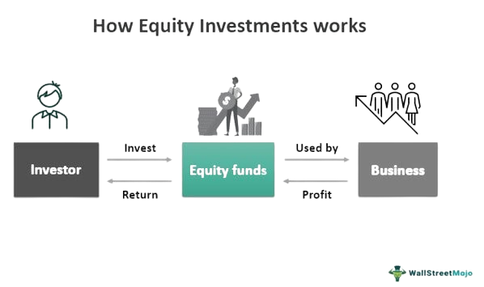

1. **Can you explain the GARP style of investing?**

GARP (Growth at a Reasonable Price) is an investment strategy that combines principles of both growth investing and value investing. The goal of GARP investors is to find stocks that are undervalued relative to their growth potential, offering a balanced approach that seeks to capitalize on growth opportunities while minimizing risk.

**Key Principles of GARP Investing**

**Moderate Growth:** GARP investors look for companies that are expected to have consistent, sustainable earnings growth. Unlike pure growth investors, who may chase the highest growth rates, GARP investors typically seek companies with growth rates in the range of 10-20% per year.

**Reasonable Valuation:** Valuation is critical in GARP investing. GARP investors use metrics like the Price-to-Earnings (P/E) ratio to ensure that the price paid for a stock is justified by its earnings growth. A common guideline is the PEG ratio (Price/Earnings to Growth ratio), which adjusts the P/E ratio by the company's growth rate. A PEG ratio of 1 or lower is often considered attractive, indicating that the stock's price is reasonable relative to its growth prospects.

**Quality Companies:** GARP investors prefer companies with strong fundamentals, including solid balance sheets, healthy cash flows, competitive advantages, and effective management teams. These companies are more likely to sustain growth over the long term.

**Risk Management:** By focusing on reasonably priced growth stocks, GARP investing aims to reduce the risks associated with investing in highly volatile, high-growth stocks. This balanced approach helps in managing potential downsides while still participating in growth opportunities.

**Advantages of GARP Investing**

**Balanced Approach:** By combining growth and value investing principles, GARP offers a balanced strategy that seeks to optimize returns while managing risks.

**Potential for Outperformance:** GARP stocks can potentially outperform in various market conditions because they are not overly reliant on high growth rates or deep value discounts.

**Focus on Quality:** Emphasizing companies with solid fundamentals tends to result in a more stable investment portfolio.

**Example of GARP Strategy in Action**

A GARP investor might look at a tech company that has a strong track record of earnings growth, a solid market position, and effective management. Suppose the company's P/E ratio is 15, and its expected annual earnings growth rate is 15%. This gives a PEG ratio of 1, indicating that the stock is reasonably priced given its growth potential. The investor might compare this to other companies in the same industry to ensure it stands out as a reasonably priced growth opportunity.

In summary, GARP investing is about finding a middle ground between growth and value investing, seeking stocks that offer good growth prospects at a reasonable price. This strategy aims to provide a well-rounded approach to equity investing, balancing the potential for high returns with a focus on value and quality.

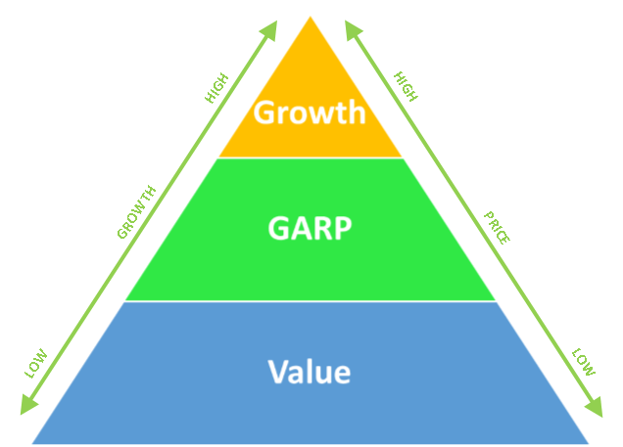

1. **When analyzing companies listed on BSE & NSE, how do you differentiate between GARP style opportunities, growth-only, and value-only companies?**

When analyzing companies listed on the BSE (Bombay Stock Exchange) and NSE (National Stock Exchange of India), differentiating between GARP (Growth at a Reasonable Price) opportunities, growth-only, and value-only companies involves evaluating several financial metrics and qualitative factors. Here’s how you can approach this differentiation:

**GARP (Growth at a Reasonable Price) Companies**

1. **Moderate Growth Rate:** Look for companies with consistent and sustainable earnings growth, typically in the range of 10-20% per year.
2. **Reasonable Valuation:**

* **Price-to-Earnings (P/E) Ratio:** Should be moderate, neither too high nor too low compared to the industry average.
* **PEG (Price/Earnings to Growth) Ratio:** A PEG ratio around 1 or lower is ideal. This indicates that the company's valuation is reasonable relative to its growth rate.

1. **Strong Fundamentals:**

* **Revenue and Earnings Stability:** Consistent revenue and earnings growth.
* **Balance Sheet Strength:** Healthy debt-to-equity ratio and strong cash flows.
* **Return on Equity (ROE):** High and sustainable ROE, reflecting efficient use of equity.

1. **Quality Management and Competitive Advantage:** Companies with capable management and a clear competitive advantage.

**Growth-Only Companies**

1. **High Growth Rate:** These companies typically exhibit high earnings growth rates, often above 20% per year.
2. **High Valuation Multiples:**

* **P/E Ratio:** Often significantly higher than the industry average, reflecting the market’s high growth expectations.
* **PEG Ratio:** May be higher than 1, indicating that the stock is priced for high growth.

1. **Focus on Expansion:**

* **Revenue Growth:** Rapidly increasing revenues, often reinvesting profits into the business for further expansion.
* **Innovation and Market Penetration:** Strong focus on innovation, capturing new markets, and scaling operations quickly.

1. **Higher Risk:** Growth-only companies are often riskier due to their dependency on continued high growth rates and may have less stable earnings.

**Value-Only Companies**

1. **Undervalued Stocks:**

* **Low P/E Ratio:** Generally lower than the market or industry average, indicating that the stock is trading at a discount to its intrinsic value.
* **Low Price-to-Book (P/B) Ratio:** P/B ratio significantly below 1 can indicate undervaluation.
* **Other Valuation Metrics:** Low Price-to-Sales (P/S) and Price-to-Cash Flow (P/CF) ratios.

1. **Stable or Modest Growth:**

* **Earnings Stability:** Steady earnings without significant growth; may have modest or stable growth prospects.
* **Dividends:** Often pay regular dividends, providing income to investors.

1. **Strong Fundamentals:**

* **Solid Balance Sheet:** Healthy debt levels and good cash reserves.
* **Asset Rich:** Companies with significant tangible assets relative to their market value.

1. **Turnaround Potential:** Sometimes value companies are in industries or sectors that are out of favor, but they have the potential for turnaround.

**Example Application**

To illustrate the differentiation with hypothetical examples from the BSE/NSE:

* **GARP Opportunity:** A mid-sized IT services company with a P/E ratio of 18, expected earnings growth of 15%, and a PEG ratio of 1.2. The company has a strong ROE, low debt, and a history of steady revenue growth.
* **Growth-Only Company:** A biotechnology firm with a P/E ratio of 60, expected earnings growth of 30%, and a PEG ratio of 2. The company is investing heavily in R&D, with rapidly growing revenues but no dividends.
* **Value-Only Company:** A well-established manufacturing company with a P/E ratio of 8, low P/B ratio of 0.7, and stable earnings growth of 5%. The company pays regular dividends and has significant tangible assets relative to its market value.

By focusing on these criteria, you can systematically categorize companies into GARP, growth-only, and value-only, helping to build a diversified and balanced investment portfolio.

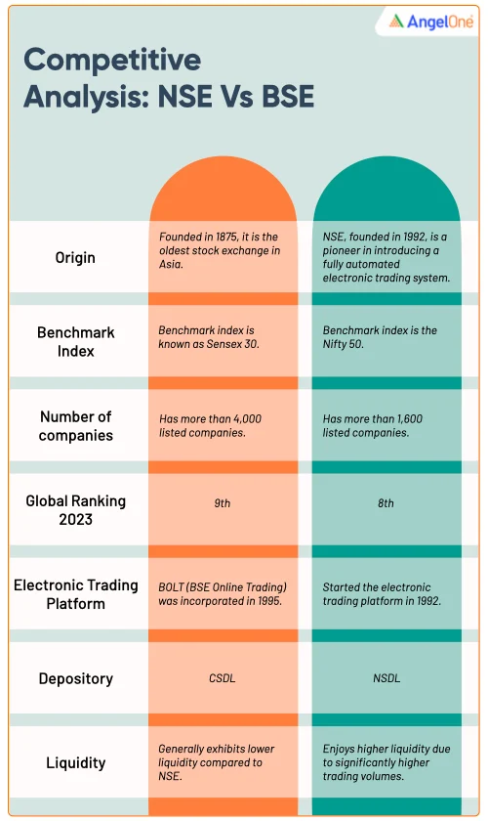

1. **How comfortable are you with Python? Please provide details about your knowledge and practical application level.**

I am quite comfortable with Python and have hands-on experience with it. I am familiar with the basics such as conditional statements, data types, slicing, indexing. I also have experience with libraries like NumPy and Pandas.

I completed a project called Covid 19 Data Analysis, where I import JSON file. Then I performed queries in SQL and generated various insights in Excel. Currently, I am furthering my Python skills by learning on Kaggle and practicing on HackerRank.

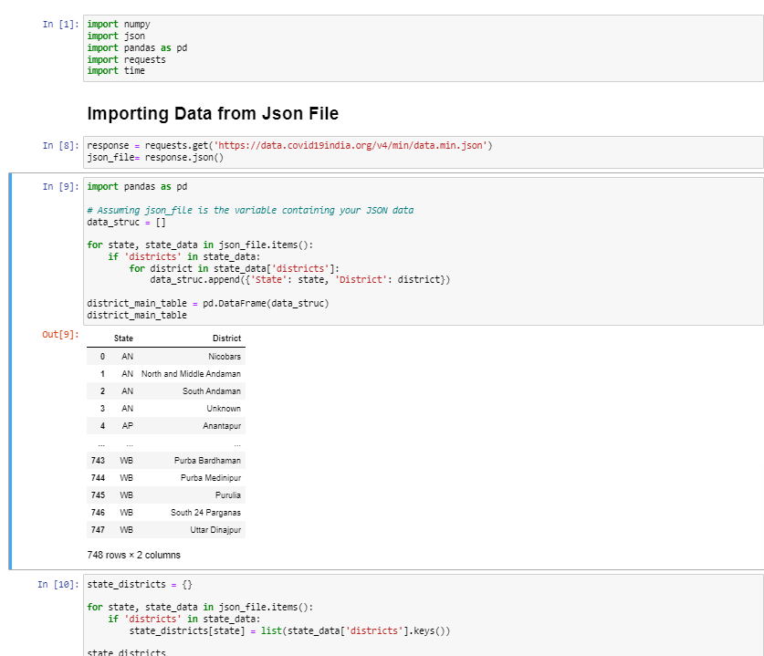

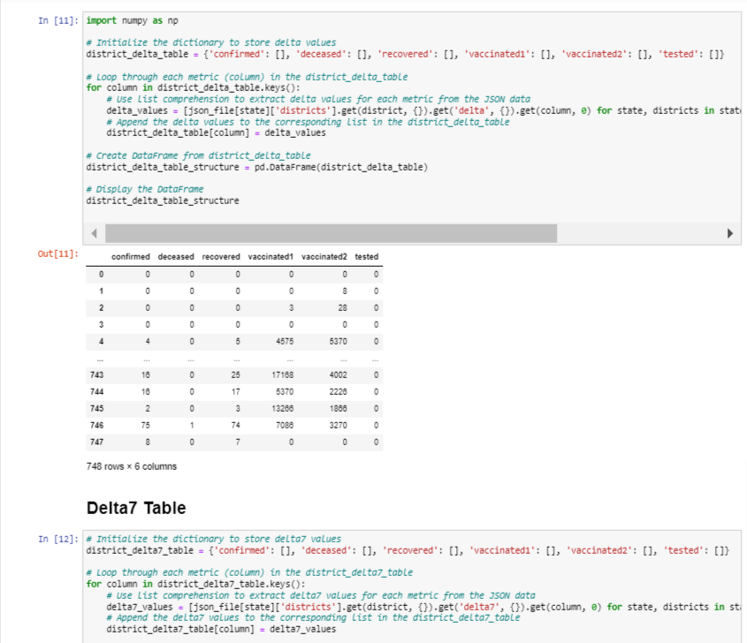

1. **Using Python, how would you determine if a company listed on BSE & NSE follows the GARP style, considering the available data for approximately 6000 companies?**

To determine if a company listed on BSE (Bombay Stock Exchange) and NSE (National Stock Exchange) follows the GARP (Growth at a Reasonable Price) investment style using Python, you'll need to analyze various financial metrics and ratios of the companies. Here's a step-by-step approach to achieve this:

1. **Data Collection:**

* Gather financial data for approximately 6000 companies listed on BSE and NSE. This data typically includes earnings growth, P/E ratio, PEG ratio, and other relevant financial metrics.
* You can use financial data providers like Yahoo Finance, Alpha Vantage, or directly from BSE/NSE APIs if available. Libraries such as yfinance, alpha_vantage, or web scraping techniques can help collect this data.

1. **Data Processing and Cleaning:**

* Clean and preprocess the data to ensure all necessary financial metrics are available for each company.
* Handle missing values, outliers, and ensure data consistency.

1. **GARP Criteria:**

* Moderate to high earnings growth (typically above 10%).
* Reasonable P/E ratio (lower than the industry average).
* PEG ratio (P/E ratio divided by earnings growth rate) close to or less than 1.

1. **Analysis:**

* Implement the logic to evaluate each company based on the GARP criteria.
* Use pandas DataFrame operations to filter and identify companies meeting the GARP criteria.

**Here's a Python script to illustrate the process:**

import pandas as pd

import yfinance as yf

**# Step 1: Data Collection**

**# For demonstration, let's assume we have a list of company tickers**

tickers = ["RELIANCE.NS", "TCS.NS", "HDFCBANK.NS"] # Add more tickers as needed

**# Function to fetch financial data for a ticker**

def fetch_financial_data(ticker):

stock = yf.Ticker(ticker)

financials = stock.financials.T

balance_sheet = stock.balance_sheet.T

cash_flow = stock.cashflow.T

return financials, balance_sheet, cash_flow

**# Collect data for each ticker**

financial_data = {}

for ticker in tickers:

try:

financials, balance_sheet, cash_flow = fetch_financial_data(ticker)

financial_data[ticker] = {

"financials": financials,

"balance_sheet": balance_sheet,

"cash_flow": cash_flow

}

except Exception as e:

print(f"Error fetching data for {ticker}: {e}")

**# Step 2: Data Processing and Cleaning**

**# Example: Extract earnings growth and P/E ratio (simplified)**

def calculate_metrics(ticker, data):

try:

earnings_growth = (data['financials']['Net Income'].pct_change() * 100).mean()

pe_ratio = data['financials']['Market Cap'] / data['financials']['Net Income']

return earnings_growth, pe_ratio.mean()

except Exception as e:

print(f"Error calculating metrics for {ticker}: {e}")

return None, None

metrics = []

for ticker, data in financial_data.items():

earnings_growth, pe_ratio = calculate_metrics(ticker, data)

if earnings_growth and pe_ratio:

metrics.append({

"ticker": ticker,

"earnings_growth": earnings_growth,

"pe_ratio": pe_ratio

})

df_metrics = pd.DataFrame(metrics)

**# Step 3: GARP Criteria**

**# Calculate PEG ratio**

df_metrics['peg_ratio'] = df_metrics['pe_ratio'] / df_metrics['earnings_growth']

**# Define GARP criteria**

def is_garp(earnings_growth, pe_ratio, peg_ratio):

return earnings_growth > 10 and pe_ratio < 20 and peg_ratio <= 1

df_metrics['is_garp'] = df_metrics.apply(lambda x: is_garp(x['earnings_growth'], x['pe_ratio'], x['peg_ratio']), axis=1)

**# Step 4: Analysis**

garp_companies = df_metrics[df_metrics['is_garp']]

print("Companies following GARP style:")

print(garp_companies[['ticker', 'earnings_growth', 'pe_ratio', 'peg_ratio']])

**Explanation:**

* **Data Collection:** The script fetches financial data for the given list of company tickers using the yfinance library.
* **Data Processing:** It calculates the earnings growth and P/E ratio for each company.
* **GARP Criteria:** It defines a function to determine if a company meets the GARP criteria based on earnings growth, P/E ratio, and PEG ratio.
* **Analysis:** It filters the companies that meet the GARP criteria and prints them.

**6 - Based on your knowledge, what insights can you derive and showcase about the following stocks: SBIN, Adani Enterprises, HUL, Tata Steels, Moil?**

Analyzing stocks involves examining various financial metrics, market conditions, and company-specific factors. Here’s a high-level analysis and insights into the mentioned stocks: State Bank of India (SBIN), Adani Enterprises, Hindustan Unilever Limited (HUL), Tata Steel, and MOIL. The insights will focus on their recent performance, financial health, market position, and growth prospects.

1. **State Bank of India (SBIN)**

**Overview:**

State Bank of India is the largest public sector bank in India, offering a wide range of banking and financial services.

**Key Insights:**

* **Financial Performance:** SBIN has shown strong growth in recent quarters with improvements in asset quality and profitability. The bank has managed to reduce its non-performing assets (NPAs), leading to better financial health.
* **Net Interest Margin (NIM):** The bank’s NIM has been improving, indicating more efficient interest income generation.
* **Digital Initiatives:** SBIN’s focus on digital banking and expansion of its digital footprint is helping in reducing costs and increasing customer base.
* **Growth Prospects:** With the Indian economy showing signs of recovery and increased credit demand, SBIN is well-positioned to benefit from these macroeconomic trends.

1. **Adani Enterprises**

**Overview:**

Adani Enterprises is a diversified conglomerate with interests in various sectors, including energy, resources, logistics, agribusiness, and more.

**Key Insights:**

* **Diversification:** Adani Enterprises’ diversified business model helps mitigate sector-specific risks. Their significant investments in infrastructure and renewable energy projects are growth drivers.
* **Revenue Growth:** The company has demonstrated robust revenue growth driven by expansion in the renewable energy sector and other infrastructure projects.
* **Debt Levels:** One area of concern is the high level of debt, which requires monitoring as it could impact financial stability, especially if interest rates rise or economic conditions worsen.
* **Market Position:** Adani’s strategic investments in key sectors like airports, ports, and green energy projects place it in a strong position to capitalize on India’s infrastructural growth.

1. **Hindustan Unilever Limited (HUL)**

**Overview:**

HUL is one of India’s largest fast-moving consumer goods (FMCG) companies, known for its strong portfolio of brands in personal care, home care, and food and beverages.

**Key Insights:**

* **Strong Brand Portfolio:** HUL’s wide range of well-established brands provides a competitive edge in the FMCG market.
* **Steady Revenue Growth:** The company has consistently delivered steady revenue and profit growth, driven by strong consumer demand and strategic product innovations.
* **Market Leadership:** HUL holds a dominant position in many segments of the FMCG market, supported by extensive distribution networks.
* **Sustainability Focus:** HUL’s focus on sustainability and corporate social responsibility resonates well with modern consumers and enhances its brand value.

1. **Tata Steel**

**Overview:**

Tata Steel is one of the leading steel manufacturing companies in India, with significant international operations.

**Key Insights:**

* **Cyclic Nature:** The steel industry is highly cyclical, with performance closely tied to economic conditions and infrastructure spending.
* **Global Presence:** Tata Steel’s international operations help diversify revenue streams but also expose it to global market risks and economic fluctuations.
* **Cost Management:** The company has been focusing on cost management and efficiency improvements to maintain profitability in a competitive market.
* **Sustainability:** Tata Steel is investing in sustainable practices and green steel initiatives, which could provide long-term benefits as global emphasis on sustainability increases.

1. **MOIL (Manganese Ore India Limited)**

**Overview:**

MOIL is a state-owned manganese ore mining company and the largest producer of manganese ore in India.

**Key Insights:**

**Market Demand:** Demand for manganese is closely tied to the steel industry since it is a key raw material in steel production.

**Revenue Volatility:** MOIL’s revenue can be volatile, reflecting the fluctuations in manganese prices and demand from the steel sector.

**Government Support:** Being a state-owned entity, MOIL benefits from strong government backing, which provides some level of stability and support for expansion projects.

**Expansion Plans:** The company has plans to expand its mining capacity, which could boost production and revenues in the long term.

**Conclusion**

Each of these companies has unique strengths and challenges:

**SBIN:** Positioned to benefit from economic recovery with strong improvements in asset quality and digital initiatives.

**Adani Enterprises:** Diverse and rapidly growing, though debt levels warrant caution.

**HUL:** Consistent performer with strong brands and market leadership.

**Tata Steel:** Well-placed in the cyclical steel market with a focus on sustainability and global operations.

**MOIL:** Tied to the steel industry’s health, with government support and expansion plans as key positives.

**7 - Are you familiar with web scraping techniques?**

Yes, I am familiar with web scraping techniques, which involve extracting data from websites. Web scraping can be performed using various libraries and tools in Python. Here are some key techniques and tools commonly used in web scraping:

**Key Techniques**

1. **HTML Parsing:** Extracting data from the HTML structure of web pages.

* **BeautifulSoup:** A library used to parse HTML and XML documents. It creates a parse tree from the page source code, making it easy to extract data.
* **lxml:** Another library for parsing HTML and XML, known for its speed and efficiency.

1. **HTTP Requests:** Sending requests to web servers to retrieve web pages.

* **requests:** A simple and popular library for making HTTP requests in Python. It supports methods like GET, POST, PUT, DELETE, etc.

1. **Browser Automation:** Simulating a browser to interact with web pages, useful for scraping dynamic content loaded by JavaScript.

* **Selenium:** A powerful tool for controlling web browsers through programs and automating web application testing.
* **Playwright:** A newer tool for browser automation that supports multiple browsers and provides features like auto-waiting.

1. **Data Storage:** Saving the scraped data in a structured format.

* **pandas:** A data manipulation library that can be used to store data in DataFrames and export to CSV, Excel, SQL, etc.
* **SQLite/MySQL:** Databases for storing large amounts of structured data.

**8. If tasked with extracting the number of NRIs across PMSs from SEBI's monthly reports for June '23, Sep '23, Dec '23, and Mar '24, how would you approach this task in terms of process, time, output file, and data accuracy?**

To extract the number of Non-Resident Indians (NRIs) across Portfolio Management Services (PMSs) from SEBI's monthly reports for June '23, Sep '23, Dec '23, and Mar '24, you can follow these steps:

1. **Understand SEBI's Monthly Reports Format**

* Review the format of SEBI's monthly reports to understand where the relevant data is located.
* Identify the section or table that contains information about NRIs and PMSs.

1. **Develop a Web Scraping Script**

* Use Python libraries like BeautifulSoup and requests to scrape the relevant data from SEBI's monthly reports.
* Write a script to navigate to the specific pages for June '23, Sep '23, Dec '23, and Mar '24 reports and extract the relevant data.
* Ensure the script handles any pagination or dynamic content loading on the SEBI website.

1. **Data Extraction Process**

* Extract the following information for each month's report:
* Number of NRIs invested in PMSs
* Total number of PMSs registered with SEBI
* Calculate the percentage of NRIs relative to the total number of PMS investors for each month.

1. **Time Considerations**

* Page load times
* Number of pages to navigate
* Processing time for parsing and extracting data
* Optimize the scraping script to minimize execution time.

1. **Output File**

* Save the extracted data into a structured format like CSV or Excel.
* Include columns for:
* Month
* Number of NRIs
* Total number of PMSs
* Percentage of NRIs among PMS investors
* Ensure the output file is well-organized and easy to analyze.

1. **Data Accuracy**

* Validate the extracted data against the original SEBI reports to ensure accuracy.
* Implement error handling and validation checks in the scraping script to handle any inconsistencies or unexpected data.
* Regularly review and update the scraping script to accommodate changes in SEBI's report format or website structure.

1. **Ethical Considerations**

* Respect SEBI's terms of service and data usage policies.
* Implement rate limiting and delays in the scraping script to avoid overloading SEBI's servers.
* Ensure compliance with data privacy regulations when handling and storing extracted data.

By following these steps and considerations, you can effectively extract the number of NRIs across PMSs from SEBI's monthly reports while maintaining data accuracy, efficiency, and ethical standards.

**9 - What configuration of devices do you believe is necessary to perform these tasks on a daily basis?**

**Hardware:** Modern computer with at least Intel i5, 12GB RAM and sufficient storage (SSD preferred).

**Software**: Python with required libraries, VSCode, reliable internet, and data visualization tools like Jupyter.

**Additional Tools:** Access to financial databases, APIs, and scraping tools. This setup enables efficient data processing, analysis, and task automation.